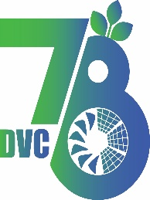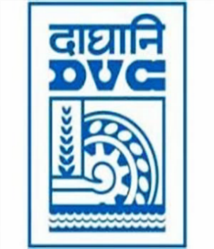 Damodar Valley Corporation

संविदा और सामग्री विभाग

**Contracts and Materials Department**

डीवीसी टावर्स; तृतीय तल; वीआइपी रोड; कोलकाता-७०००५४ टेली फ़ैक्स न०-०३३-२३५५-२९३६

**DVC Towers; 3rd Floor; VIP Road, Kolkata – 700054 Tele fax No.-033 – 2355 –2936.**

**E-Tender Notice**

Damodar Valley Corporation invites online bids (**Open**) from the eligible bidders for:

|  |  |  |
| --- | --- | --- |
| **REFERENCE NO.** | **Description of item** | **Tender Downloading Period and Time** |
| **DVC NIT NO:** - DVC/Tender/Head Quarter/SPE/CMM/Works and Service/00079/Capital dated 07.08.2025  ****************************************  CPPTender ID**: - 2025_DVC_244223_1** | Supply and Installation, Testing and Commissioning of Valve Regulated Lead Acid (VRLA) battery along with  complete dismantling and buyback of old unserviceable VRLA batteries at various locations of DVC Power Houses and Substations | From:  07.08.2025 at 12:00 Hrs. (IST)  To  04.09.2025 at 12.00 Hrs. (IST) with Pre-Bid meeting on 22.07.2025 at 12:00 Hrs. through online mode through Microsoft Team |

For further details and to participate in tender, please log on:

<https://etenders.gov.in/eprocure/app>

Note: For any Technical Queries call: - **0120-4200 462, 0120-4001 002, 0120-4001 005,**

**0120-6277 787**

**E-Mail Support:** **Technical support-** [**eproc@nic.in**](mailto:eproc@nic.in)