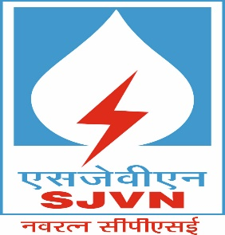 | एसजेवीएन लिमिटेड SJVN Ltd.  (भारत सरकार तथा हिमाचल प्रदेश सरकार का सांझा उपक्रम)  (A Nav Ratna Company)  (6X250MW नाथपा झाकड़ी जल विद्युत स्टेशन)  प्रापण एवं संविदा विभाग, झाकड़ी, जिला शिमला, हि॰ प्र॰-. 172201  फोन. 01782-275236,275459,275106, फ़ैक्स 01782-234049, 275106,  http://www.sjvn.nic.in  GSTIN No. 02AAICS1307F1ZY  सिन् संख्या (CIN No.) L40101HP1988GOI008409 |  | 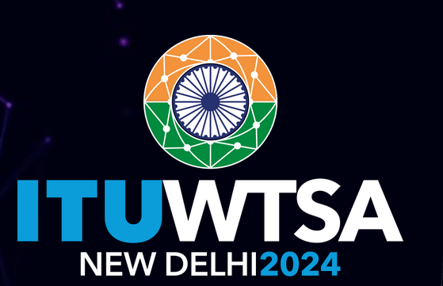

PRESS NOTICE
E-Tendering No. Package (P)-354(O&M)

Online bids (e-tender) on International Competitive Bidding (ICB) are invited only from the manufacturers or their authorized representative on behalf of SJVN Limited for “Supply of Hard Coating Powder for HVOF Thermal Spray Process of the NJHPS, SJVN Ltd. Jhakri”. For details, please visit websites www.sjvn.nic.in, https://etender.sjvn.co.in & www.eprocure.gov.in.
Last date for downloading of bid documents is 14/11/2025(12:00 Hrs.).
Last date for bid submission is 14/11/2025 (13:00 Hrs.).
Amendment (s), if any, shall be issued on above websites only.
.
For and on behalf of SJVN Ltd.

Dy. General Manager,
P&C Deptt. NJHPS, SJVN Ltd., Jhakri

