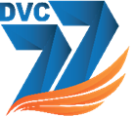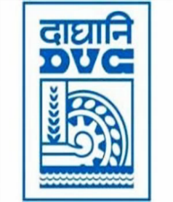 Damodar Valley Corporation

संविदा और सामग्री विभाग

**Contracts and Materials Department**

डीवीसी टावर्स; तृतीय तल; वीआइपी रोड; कोलकाता-७०००५४ टेली फ़ैक्स न०-०३३-२३५५-२९३६

**DVC Towers; 3rd Floor; VIP Road, Kolkata – 700054 Tele fax No.-033 – 2355 –2936.**

**E-Tender Notice**

Damodar Valley Corporation invites online bids (**QCBS**) from the eligible bidders for:

|  |  |  |
| --- | --- | --- |
| **REFERENCE NO.** | **Description of item** | **Tender Downloading Period and Time** |
| **DVC NIT NO:** - DVC/Tender/Head Quarter/CMG/CMM/Works and Service/00006/Capital dated 04.06.2025  ****************************************  CPPTender ID**: - 2025_DVC_236134_1** | Engagement of Consultant for Project Management Consultancy for efficient execution of Thermal Projects of DVC for Koderma TPS (Phase-II), Raghunathpur TPS (Phase-II) and Durgapur TPS | From:  04.06.2025 at 12:00 Hrs. (IST)  To  02.07.2025 at 12.00 Hrs. (IST) with Pre-Bid meeting on 18.06.2025 at 12:00 Hrs. through online mode through Microsoft Team |

For further details and to participate in tender, please log on:

<https://etenders.gov.in/eprocure/app>

Note: For any Technical Queries call: - **0120-4200 462, 0120-4001 002, 0120-4001 005,**

**0120-6277 787**

**E-Mail Support:** **Technical support- eproc@nic.in**