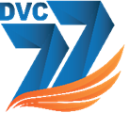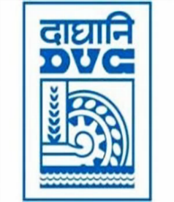Damodar Valley Corporation

संविदा और सामग्री विभाग

**Contracts and Materials Department**

डीवीसी टावर्स; तृतीय तल; वीआइपी रोड; कोलकाता-७०००५४ टेली फ़ैक्स न०-०३३-२३५५-२९३६

**DVC Towers; 3rd Floor; VIP Road, Kolkata – 700054 Tele fax No.-033 – 2355 –2936.**

**E-Tender Notice**

Damodar Valley Corporation invites online bids (**Open Tender with E-Reverse Auction**) from the eligible bidders for:

|  |  |  |
| --- | --- | --- |
| **REFERENCE NO.** | **Description of item** | **Tender Downloading Period and Time** |
| **DVC NIT NO:** - DVC/Tender/Head Quarter/SPE/CMM/Supply/00060/Capital dated 25.03.2025  ****************************************  CPPTender ID**: - 2025_DVC_231137_1** | Procurement of 03 nos. of 31.5 MVA, 132/34.5KV Power Transformers | From:  25.03.2025 at 13:00 Hrs. (IST)  To  22.04.2025 at 13.00 Hrs. (IST) with Pre-Bid meeting on 07.04.2025 at 12:00 Hrs. through online mode through Microsoft Team |

For further details and to participate in tender, please log on:

<https://etenders.gov.in/eprocure/app>

Note: For any Technical Queries call: - **0120-4200 462, 0120-4001 002, 0120-4001 005,**

**0120-6277 787**

**E-Mail Support:** **Technical support- eproc@nic.in**