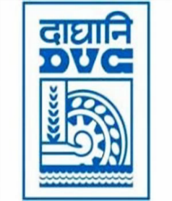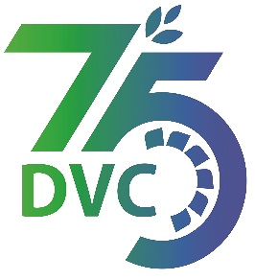 **damaooadr GaaTI inagama**

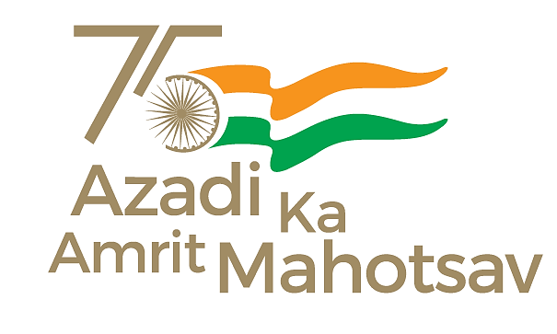

Damodar Valley Corporation

संविदाऔरसामग्रीविभाग

**Contracts and Materials Department**

डीवीसीटावर्स;तृतीयतल;वीआइपीरोड;कोलकाता-७०००५४टेलीफ़ैक्सन०-०३३-२३५५-२९३६

**DVC Towers; 3rd Floor; VIP Road, Kolkata – 700054 Tele fax No.-033 – 2355 –2936.**

**E-Tender Notice**

Damodar Valley Corporation invites online bids (**Open Tender with E-Reverse Auction**) from the eligible bidders for:

|  |  |  |
| --- | --- | --- |
| REFERENCE NO. | Description of item | Tender Downloading Period and Time |
| **DVC NIT NO:**- **DVC/Tender/Head Quarter/SPE/CMM/Works and Service/00069/Capital dated 17/12/2024.** ***************************  CPPTender ID**:-**2024_DVC_219928_1 | *Supply, Erection, Testing and Commissioning for Diversion/Shifting of 132 KV lines due to construction of new unit 1x800MW at DTPS*  *.* | From:  17.12.2024 at 18.00 Hrs.(IST)  TO  14.01.2025 at 12.00 Hrs.(IST) |

For further details and to participate in tender, please log on:

<https://etenders.gov.in/eprocure/app>

Note: For any Technical Queries call:-**0120-4200 462, 0120-4001 002, 0120-4001 005,**

**0120-6277 787.**

**E-Mail Support:Technical - support-eproc(at)nic(dot)in**