MUMBAI PORT AUTHORITY

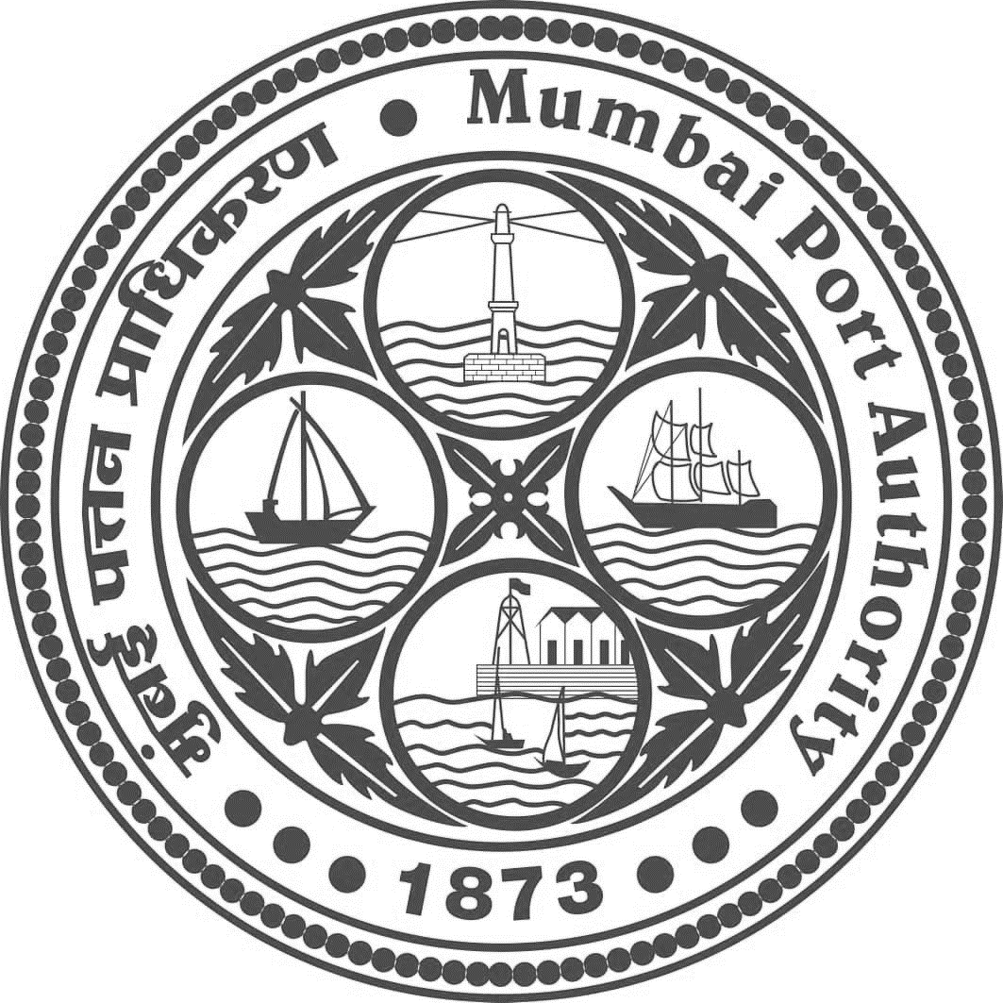

**NOTICE INVITING TENDER**

Mumbai Port Authority invites online e-Tenders in two cover bidding process for **Tender No.GAD 02/2022 – Tender for transportation of CISF personnel by vehicles for a period of three years.** Details of the tender are available on MbPA's website **http://www.mumbaiport.gov.in** AND **http://www.eprocure.gov.in**

**Secretary**