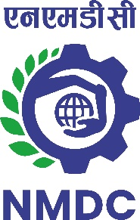

**NMDC LIMITED**

**(A Government of India Enterprise)**

**‘Khanij Bhavan’, 10-3-311/A, Castle Hills, Masab Tank, Hyderabad –500 028**

**Corporate Identity Number (CIN) - L13100AP1958GOI001674**

**EXPRESSION OF INTEREST**

**EOI No: HO(Contracts)/EOI/BC/Transporting IOF/2024/208 Dated 22.05.2024**

NMDC Limited, A “NAVARATNA” Public Sector Company under Ministry of Steel, Govt. of India, invites **Expression of Interest (EOI)** from experienced firms for identifying the interested parties for **Transporting iron ore fines through Belt Conveyors, Stacking and Loading into Rail Wagons including Railway Works on BOOM basis at Bacheli Complex, Chhattisgarh*.***

The EOI documents can be viewed and / or downloaded from **22.05.2024 to 19.06.2024 from following website links;**

1. NMDC website – <https://www.nmdc.co.in>
2. Central Public Procurement portal – <https://www.eprocure.gov.in/epublish/app> and search EOI documents through EOI number

For accessing the EOI documents from NMDC web site for the first time; on-line registration is required as **‘New User’** in **‘Tenders’** section at website link <https://www.nmdc.co.in> of NMDC. The intending parties are required to visit the NMDC’s website and / or CPP Portal for corrigendum, if any, at a future date.

For further clarification, the following can be contacted –

General Manager (C, P & S), NMDC Limited, Hyderabad, Telephone No. 040 – 23532800, email: [contracts@nmdc.co.in.](mailto:contracts@nmdc.co.in)

**Executive Director (Works)**