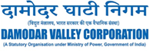


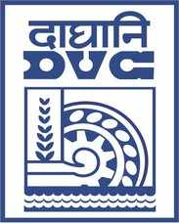

E-TENDER NOTICE

Damodar Valley Corporation invites online bids (Open) from the eligible bidders for:
REFERENCE NO. | Description of item | Tender Downloading Period and Time
DVC NIT NO: DVC/Tender/Head Quarter/SPE/CMM//Works and Service/105861 dated 22.06.2026  ****************************************  CPP Tender ID: - 2026_DVC_281370_1 | Supply, Erection, Testing and Commissioning for Diversion/shifting of 132KV and 33 KV lines due to buttressing andfurther raising of existing ash dykes of CTPS. | From:  22.06.2026 at 12:00 Hrs. (IST)  To  20.07.2026 at 12.00 Hrs. (IST)

For further details and to participate in tender, please log on:
https://etenders.gov.in/eprocure/app

Note: For any Technical Queries call: - 0120-4200 462, 0120-4001 002, 0120-4001 005, 0120-6277 787

E-Mail Support: Technical support- eproc@nic.in

