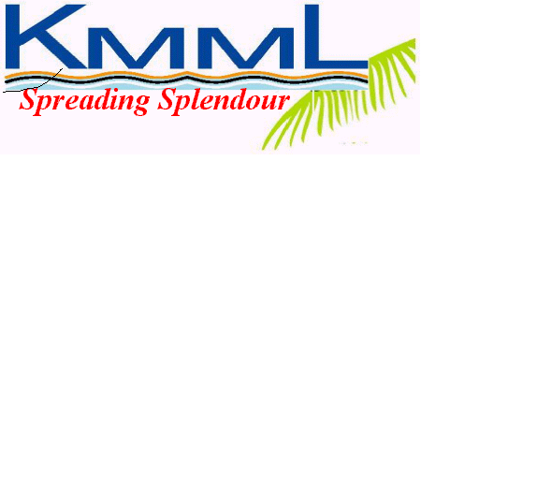 **The Kerala Minerals& Metals Limited**

(A Govt. of Kerala Undertaking)

Mineral Separation Unit,

Kovilthottam, Chavara,

Kollam – 691583, Kerala.

Phone : (0476)2680047, 2680048, 2682727, web site : www.kmml.com

E-mail [md@kmml.com](mailto:md@kmml.com); [hodms@kmml.com](mailto:hodms@kmml.com)

**NOTICE INVITING EXPRESSION OF INTEREST**

|  |  |
| --- | --- |
| Tender ID | Work Description |
| KMML/MS/VA/MT-01 | **KMML INVITES** **EXPRESSION OF INTEREST (EOI) FOR THE SELECTION OF TECHNICALLY COMPETENT BIDDERS TO DEVELOP AND IMPLEMENT THE TECHNOLOGY FOR PROCESSING OF MONAZITE RICH TAILINGS/ RESIDUE TO OBTAIN THE MIXED RARE EARTH (RE)COMPOUNDS AND SEPARATION OF RARE EARTH ELEMENTS.** |

Tender documents are available at HOD Office of KMML MS Unit w.e.f. 26.05.2025 and the EOI shall be returned on or before 25.06.2025. Please visit KMML website www.kmml.com for further details & information.

Date: 23.05.2025 -sd-

Place: Chavara Deputy . General Manager & HOD (MS)